Spring 2000

Class II Information Technology Engineer Examination (Morning)

Questions must be answered in accordance with the following:
Question Nos. | Q1 to Q80
Question Selection | All questions are compulsory
Examination Time | 9:30-12:00 150 minutes
Instructions:
1. Use an HB pencil.
If you need to change an answer, erase your previous answer completely and neatly. Wipe away any eraser debris.
2. Mark your answers in accordance with the instructions below. Your answers will not be graded if you fail to comply with the instructions. Do not mark or write on the answer sheet outside of the prescribed places.
(1) Examinee Number
Write your examinee number in the space provided, and mark the appropriate space below each digit.
(2) Date of Birth
Write your date of birth (in numbers) exactly as it is printed on your examination admission card, and mark the appropriate space below each digit.
How to Mark Your Answers
(3) Answers
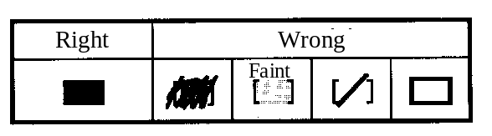
Select one answer (responce option)(A through D)
for each question.
Mark your answer as shown in the following sample
Question.

[Sample Question] In which month is the Spring Information Technology Engineer Examination conducted?

a) 2 | b) 3 | c) 4 | d) 5

Since the correct answer is "C" (4), mark your answer sheet as follows:

[Sample Reply] a) b) c) d)
Do not open the exam booklet until instructed to do so.
Inquiries about the exam questions will not be answered.

Q1. Given the following five pieces of data, how much is the variance?

3, 2, 7, 7, 6

a) 2.1 b) 2.3 c) 2.4 d) 4.4

Q2. An integer number from 1 through 100 is generated randomly. What percent is the probability that it is neither a multiple of 3 nor 5?

a) 41 b) 47 c) 53 d) 59

Q3. Which of the following rows represents the same value in binary, octal, decimal, and hexadecimal?

 | Binary | Octal | Decimal | Hexadecimal
a) | 111 | 10 | 8 | 8
b) | 1010 | 12 | 10 | A
c) | 1100100 | 256 | 100 | 64
d) | 11111111 | 377 | 256 | FF

Q4. If a positive decimal number is shifted 4 bits to the left, by what factor is the original value multiplied? Assume there is no overflow.

a) 0.0625 b) 0.25 c) 4 d) 16

Q5. What is the two’s complement of the 8-digit binary number 10110101?

a) 01001010 b) 01001011 c) 10110100 d) 10110110

Q6. Which is the value of the expression 0.0011₂ ÷0.001₂? The numbers in the form at x.xx₂ represent binary numbers.

a) 0.00001₂ b) 0.000011₂ c) 0.11₂ d) 1.1₂
Q7. What is the bit pattern for the decimal number +432 when expressed in packed decimal representation? Assume that the last four bits represent the sign, where “1100” represents + and “1101” represents −.

a) 0000 0001 1011 1100 b) 0001 1011 0000 1100
c) 0100 0011 0010 1100 d) 0100 0011 0010 1101

Q8. A numeric value is expressed as a 16-bit floating point number in the format given in the figure. Which is the correct representation of the decimal number 0.375? According to the normalized representation used here, the fractional part and the exponent part are adjusted so that the highest order digit of the fractional part may be non-zero.

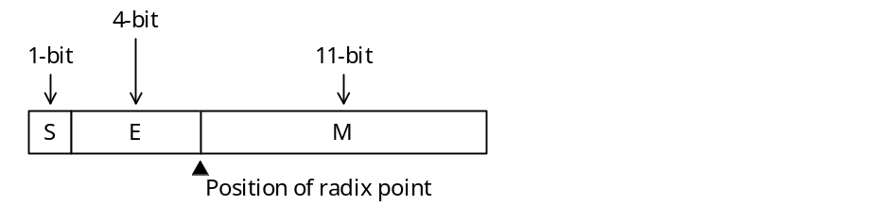
S: Sign of the fractional part (0: positive, 1: negative)
E: Exponent part (base 2 assumed, a negative value is a 2’s complement)
M: Fractional part (represented as an absolute binary value)

a) 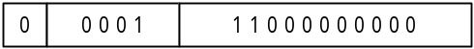

b) 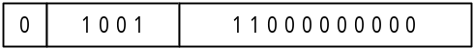

c) 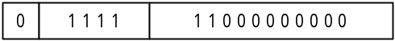

d) 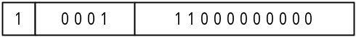

Q9. When drawing a circle of area S, by about what percent or less is it necessary to set the relative error of radius r in order to keep the relative error of S at 1% or less?

a) 0.1 b) 0.5 c) 1 d) 2

Q10. The truth table for the logical operation “x  y” is as follows. Which of the expressions shown under the table is equivalent to this operation?

x | y | x  y
True | True | False
True | False | False
False | True | True
False | False | False

a) x OR (NOT y) b) (NOT x) AND y
c) (NOT x) AND (NOT y) d) (NOT x) OR (NOT y)

Q11. Which logical expression is equivalent to • • + • B • + A • • + A• B • ? Here, “•” is used to represent a logical product, while “+” is used to represent a logical sum, and 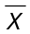 is the negation of X.

a) A b) B c) d)

Q12. Given an 8-bit code that includes a parity bit, which of the following bit operations would be used to find the lower order 7 bits other than the highest order parity bit?

a) AND the value with the hexadecimal 0F.
b) OR the value with the hexadecimal 0F.
c) AND the value with the hexadecimal 7F.
d) XOR the value with the hexadecimal FF.

Q13. The values at the nodes in the figure satisfy the inequalities A₄ < A₂ < A₆ < A₅ < A₇ < A₁ < A₃. What kind of tree gives this type of relationship?

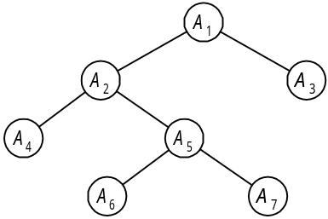

a) Binary search tree b) AVL tree c) B tree d) Heap

Q14. The text representation for entering a binary tree is defined as follows. Which is the correct text representation when numbers are assigned to nodes as shown in the figure?

[Text Representation]
(1) Represented as (node number on left subtree or text representation, node number, node number on right subtree or text representation).
(2) x is written when the subtree is empty.

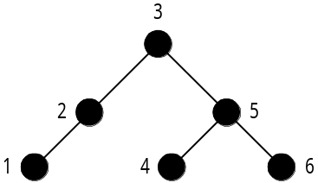

a) ( (1, 2), 3, (4, 5, 6) ) b) ( (1, 2, , 3), x, (4, 5, 6) )
c) ( (1, 2, x), 3, (4, 5, 6) ) d) ( (1, 2, x), 3, (6, 5, 4 ) )

Q15. In this heap, the value of a parent node is less than the values of child nodes. When inserting a node into this heap, an element is added at the very end. If that element is less than the parent node, the parent and child are exchanged with each other. If element 7 is added to the heap at the position marked by the asterisk (*), what element will end up at position A?

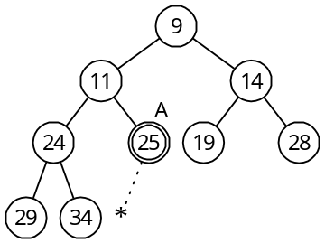

a) 7 b) 11 c) 24 d) 25

Q16. The flow chart below represents an algorithm for finding the total sum of integers from 1 to N (1 + 2 + ... + N, where N ≥ 1). Which expression should be entered in “a” to complete this algorithm?

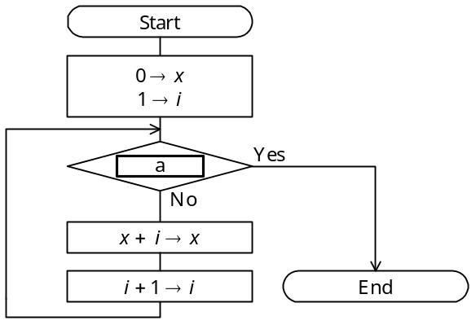

a) i = N b) i < N c) i > N d) x > N

Q17. How many data comparisons are made for n pieces of data when using bubble sorting?

a) n b) n log n c) d) 2^{n}

Q18. In high-speed computing, which of the following methods is used to overlap multiple instructions in execution, such that a single instruction is divided into n independent processing stages so that instructions in each stage may be executed in parallel?

a) out-of-order execution b) cache memory
c) pipeline processing d) branch prediction

Q19. When specifying an operand address using machine language instruction indexing, what is the effective address for the values given in the table?

Index register value | 10
Instruction address value | 100
Address where instruction is stored | 1000

a) 100 b) 110 c) 1100 d) 1110

Q20. Given a processor having a basic operating time (clock time) of three nanoseconds, what is the approximate average performance of this processor in MIPS if the number of clock cycles required to execute an instruction and the frequency for that instruction are as shown in the table?

Instruction type | Clock cycles required to execute instruction | Frequency
Operations between registers | 4 | 40%
Operations between memory and  registers | 8 | 50%
Unconditional branches | 10 | 10%

a) 5 b) 30 c) 50 d) 100

Q21. A processor accesses the main memory in 60 nanoseconds and cache memory in 10 nanoseconds. If there is an 80% probability that data to be accessed exists in cache memory, what is the average memory access time in nanoseconds for that processor?

a) 14 b) 20 c) 50 d) 70

Q22. If the specifications for a dual-sided, double density floppy disk are as shown in the table, what is the data storage capacity of one floppy disk in kilobytes? In this problem, 1 kilobyte is 1,024 bytes.

Number of tracks (single-sided) | 80 tracks
Number of sectors / track | 26 sectors
Data length | 256 bytes / sector

a) 520 b) 1,040 c) 1,064 d) 1,080

Q23. Assume there is a disk with a rotation rate of 4,200 revolutions per minute and an average seek time of 5 milliseconds. What is the average latency in milliseconds for this disk?

a) 7 b) 10 c) 12 d) 14

Q24. What is the correct relationship among the elements a through c, which affect the access time, when reading 100 kilobytes of data stored continuously on a hard disk having the configuration and specifications shown in the figure?

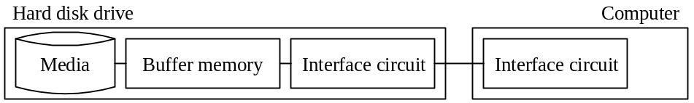

[Hard Disk Drive Specifications]
(1) Rotation rate of medium: 6,000 rpm
(2) Average amount of data per track: 100 KB
(3) Average seek time: 10 ms
(4) Data transfer rate of interface: 5 MB/sec

[Elements Affecting Access Time]
a. Total of seek time and search time for head
b. Data transfer time between media and buffer memory
c. Data transfer time between computer memory and the computer

a) a < b < c b) a < c < b c) b < a < c d) c < b < a

Q25. Which of the following most accurately describes the performance of a magnetic disk drive?

a) The access time of a magnetic disk drive decreases if the rotation rate is raised or if the seek time is reduced.
b) The storage capacity of such a drive is determined by the storage capacity per track and the number of tracks per cylinder.
c) The data access time includes both the pre-processing time of the processor and the post-processing time after data transfer.
d) The data transfer rate is determined only by the rotation rate of the disk.

Q26. This media is a 12-cm diameter, 1.2-mm thick disk having a storage capacity of 4.7 GB with a single sided single layer. It is used for storing compressed motion images such as movies in MPEG2 format. What type of medium is this?

a) CD b) DVD c) LD d) MD

Q27. Which of the following most accurately describes the RS-232C standard?

a) It is capable of duplex, bidirectional communications.
b) It has a maximum communications rate of 19,200 bits per second.
c) It allows a daisy chain connection.
d) It is a parallel interface.

Q28. Which of the following most accurately describes a system bus?

a) Widely used in PCs, this standard is for serial transfer of data with a modem or peripheral device.
b) It is a digital signal transfer path shared by multiple devices within the computer.
c) It is a device for converting digital signals to analog signals and analog signals to digital signals.
d) It is a mechanism for transferring data between I/O devices and main memory independently from the CPU.

Q29. Which of the following most accurately describes the I/O interface?

a) ATA/ATAPI-4 (usually called IDE) is an interface that transfers data one bit at a time serially and is used for connecting a modem, mouse, etc.
b) RS-232C is an interface for transferring 8-bit data in parallel and is often used to connect printers.
c) USB has two transfer modes for high speed peripheral devices and low speed peripheral devices and is typically used in high speed mode for printers, scanners, modems, etc.
d) As an infrared communications standard, the Centronics interface is used for data conversions between a notebook computer and a portable information device, transmitting data to a printer, etc.

Q30. Which of the following is an accurate description concerning printers?

a) It is possible to make carbon copies when using an ink jet printer.
b) It is impossible to print chinese characters (kanji) or illustrations with a dot impact printer.
c) Color printing is impossible with a thermal transfer printer.
d) It is possible to print illustrations and images with a laser printer.

Q31. The following figure illustrates the logic circuit for a full adder. In the figure, if 1 is input for x, 0 for y, and 1 for z, then what are the output values for c (carry digit) and s (sum)?

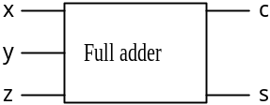

 | c | s
a) | 0 | 0
b) | 0 | 1
c) | 1 | 0
d) | 1 | 1

Q32. What is the correct order of processing and modes for the virtual storage of a paging system when accessing a page that is not in real storage? Assume that there is no page currently available in real storage.

a) Determine the replacement page → page out → page fault → page in
b) Determine the replacement page → page in → page fault → page out
c) Page fault → determine the replacement page → page out → page in
d) Page fault → determine the replacement page → page in → page out

Q33. During the execution of a process, it transits through the following states: ready, running and wait. Which is the most appropriate description regarding the state transition of a process?

a) If more than one process which alternately perform CPU processing and I/O processing are executed simultaneously, each process transits only between the running and wait states.
b) The ready state is that state where the process waits for CPU allocation. Generally, there may be more than one ready process, and then a queue is formed.
c) On systems that perform time sharing processing, a process in the ready state transits to the wait state once a certain fixed amount of time passes.
d) On a multi-programming system, there is more than one process in the running state even when there is only one CPU.

Q34. Which is the most appropriate definition of the role of task management?

a) The application program creation load is reduced by providing a device-independent means of accessing various types of auxiliary storage devices.
b) Real storage is used effectively by providing a virtual storage space.
c) I/O devices are operated accurately and efficiently by performing I/O device control.
d) The CPU is used effectively by performing multi-programming control.

Q35. The following table lists the priority of three tasks and the amount of time that each task occupies the CPU and an I/O device when each task is executed independently. How many milliseconds is the CPU idle, starting from the point when all three tasks became ready simultaneously to the point that they have all terminated? Assume there is one CPU, that the I/O for all tasks can be performed in parallel, and that OS overhead is negligible.

Task | Priority | Time required to execute each task independently
A | High | For each task:  CPU 5 milliseconds → I/O 8 milliseconds →  CPU 2 milliseconds
B | Medium
C | Low

a) 3 b) 4 c) 5 d) 6

Q36. As an operating system repeatedly allocates and frees storage space, many physically separated unused areas appear. What is this phenomenon called?

a) Compaction b) Swapping
c) Fragmentation d) Paging

Q37. Which of the following is a system for loading the necessary segments at run time by dividing the load module into several segments to be executed exclusively?

a) Overlay b) Swapping
c) Dynamic relocation d) Dynamic linking

Q38. Which of the following is an accurate description of the characteristics of a reentrant program?

a) A reentrant program operates while calling procedures required at run time from an auxiliary storage device. This is an effective technique when there is a limit on the amount of main storage at run time.
b) A reentrant program is one that can call itself from within a procedure.
c) When used by more than one task, a reentrant program can be temporarily used by one task.
d) Even if executed in parallel by more than one task, a reentrant program can return correct results to each separate task.

Q39. Which is an accurate description of a compiler?

a) Interprets source programs and executes them.
b) Analyzes syntax and semantics and generates corresponding object code.
c) Edits intermediate code.
d) Stores the load module in main memory.

Q40. Which is an appropriate definition of a "data warehouse"?

a) A data warehouse manages data used by information systems. By eliminating the unnecessary duplication of data and by centrally managing data handled separately by department, data resources can be obtained easily because
b) A data warehouse is technology for reducing the volume of data by limiting redundancy of data. This technology is required in image processing because the volume of data handled is excessively large.
c) A data warehouse is a collection of chronologically ordered data that has been compiled depending on the purpose of use. It is useful for decision support, because it allows the utilization and analysis of information from various angles.
d) A data warehouse is software which allows communication among users and the sharing of information among them to make group works efficient.

Q41. If the bit pattern "00000 10111 11010" appears in the data field of the transfer frame of an HDLC protocol receiver, what was the original bit pattern sent? Assume that priority of the bit pattern is from left to right and that the space used every 5 bits is meaningless.

a) 00001 01111 1010 (The last 0 of the five consecutive 0's in the receiver's bit pattern is deleted.)
b) 00000 01111 1010 (The 1 in the 6th bit from the left in the receiver's bit pattern is deleted.)
c) 00000 11111 1010 (The 0 in the 7th bit from the left in the receiver's bit pattern is deleted.)
d) 00000 10111 1110 (The 0 in the 13th bit from the left in the receiver's bit pattern is deleted.)

Q42. Which is an accurate description regarding the rules for the session layer of the OSI basic reference model?

a) There are protocols for the sequence of data to be transmitted, error detection and recovery process for lost data, and data multiplexing.
b) There are protocols for remote data access, file transfer, etc.
c) There are protocols for error control to do transparent error-free data transfer recovery control procedures, send/receive timing, etc. between adjacent systems.
d) There are protocols for establishing a logical communication path managing interactive actions to support orderly data exchange and exception reporting.

Q43. The transmitter sees transfer data as a polynomial, and the remainder that results when divided by a predetermined generating polynomial is added to the transfer data as a code used for checking the data. The receiver divides the received data by the same generating polynomial to determine if there has been an error, based on whether or not the polynomial divides into the data. Which error control method is used in this data transfer?

a) Group check b) Cyclic redundancy check
c) Vertical parity check d) Horizontal parity check
Q44. When transferring messages consisting of 90 characters each in start-stop transmission using a 14,400 bits per second line, how many messages can be sent in one minute? Assume that 8-bit, no parity is used for each character and that 1 bit is used for the start signal and stop signal, respectively. Also, assume that line availability is 80%.

a) 12 b) 16 c) 768 d) 960

Q45. Which is an accurate statement regarding the characteristics of a bus LAN that uses a CSMA/CD system?

a) No node can communicate until a free token is received.
b) The entire LAN system stops if a failure occurs at the control station.
c) Even if the volume of communication increases, ability to communicate within a fixed period of time is guaranteed.
d) If a node detects the collision of a transmitted signal, the signal is re-sent after waiting a random amount of time.

Q46. Which piece of hardware is capable of performing protocol conversion between LAN systems whose transport and higher layers are different?

a) Gateway b) Bridge c) Repeater d) Router

Q47. In the hierarchical file system shown in the figure below, what is the relative pathname that identifies file C2 when the current directory is B1? In the pathname specification, ".." represents the parent directory, and "/" represents the root directory when used at the beginning of the pathname, or is used to delimit directory names and file names when used in the middle. Also, assume that the boxes ( ) represent directories.

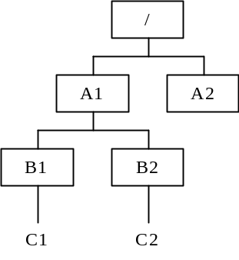

a) | ../A1/B2/C2 |  |  | b) | ../B2/C2
c) | A1/B2/C2 |  |  | d) | /A1/B2/C2

Q48. In the case of relational database operations, what operation creates Table 3 from Tables 1 and 2?

Table 1 |  |  | Table 2 |  |  | Table 3
Number | Product name |  | Number | Ordered by |  | Number | Product name | Ordered by
010 | PC unit |  | 010 | Company A |  | 010 | PC unit | Company A
011 | Display |  | 011 | Company B |  | 011 | Display | Company B
020 | Printer |  | 020 | Company C |  | 020 | Printer | Company C
025 | Keyboard |  | 025 | Company D |  | 025 | Keyboard | Company D
030 | Modem |  | 030 | Company E |  | 030 | Modem | Company E

a) Join b) Projection c) Selection d) Inclusion
Q49. In the case of database systems, what method is used to prevent logical inconsistencies when more than one transaction processing program simultaneously updates the same database?

a) Normalization b) Integrity constraint
c) Data-centered design d) Exclusive access control

Q50. Which operation is used to restore a database using backup files and logs when the storage media on which a database is stored fails (media failure)?

a) Archive b) Commit
c) Check point dump d) Roll forward

Q51. In the case of a client-server system, which process is most appropriately performed by the server?

a) Print previews
b) Database updates
c) Checking the format of input data
d) Displaying pull-down menus

Q52. In which system does one computer function normally while the other is in the wait status?

a) Dual system
b) Duplex system
c) Multi-processing system
d) Load share system

Q53. Which is the best indicator for evaluating on-line system performance, particularly business processing performance?

a) Execution wait time b) Channel usage
c) Transaction response time d) Paging count

Q54. One server, three clients, and two printers are connected to a LAN as shown in the figure below. In this system, the server outputs data to a printer based on instructions from a client. Which formula gives the availability of this system? The system is considered normal if one out of three clients is running and if either of the two printers are running. Assume that there is no LAN failure.

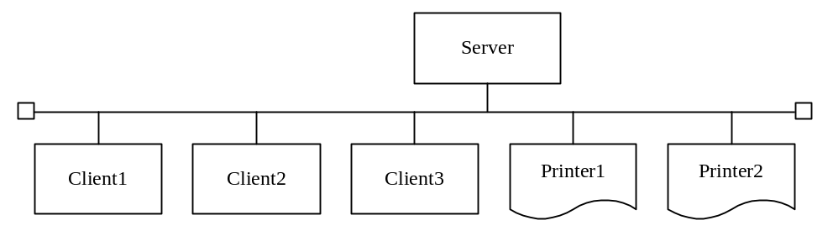

Device | Availability
Server | a
Client 1 | b
Client 2 | b
Client 3 | b
Printer 1 | c
Printer 2 | c

a) ab³ c² b) a (1 − b³ ) (1 − c² )
c) a (1 − b)³ (1 − c)² d) a (1 − (1−b)³ ) (1 − (1 − c)² )

Q55. The curve in the figure below is a graph of frequency of failure. Which reason best explains why the part in the graph indicated by "a" is flat?

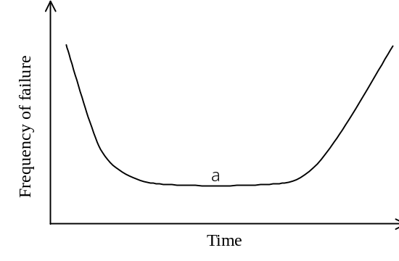

a) Because this is the period where there is a fixed probability of initial failures.
b) Because nearly all initial failures have occurred and this is the period where there is a fixed probability of accidental failure.
c) Because nearly all initial failures and failures due to friction have occurred.
d) Because this is the period where wear-out failure occurs evenly.

Q56. Which is the most appropriate description of a waterfall model? (A waterfall model is a methodology used in system development.)

a) Applications are designed and implemented in parts and this process is repeated.
b) Since system development proceeds in sequence of process (phase), system development efficiency decreases markedly if an attempt is made to go back.
c) An operable prototype model is developed, the requirement specifications are checked and evaluated at an early stage.
d) Development takes a short period of time due to user participation, development by a small number of people, and the use of development tools.

Q57. The figure below is one part of a DFD at a certain level in a hierarchical DFD. Which is the most appropriate method of describing the DFD of the level immediately below? Assume that the processes in the level immediately below Process n are numbered processes of the form n-1, n-2, etc.

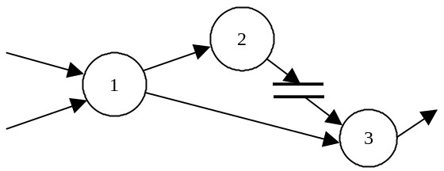

a) 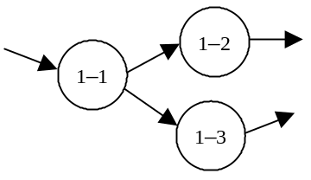 b) 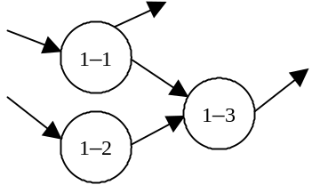

c) 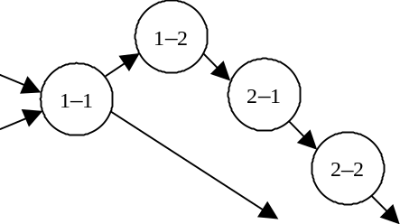 d) 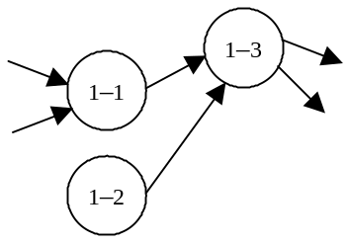

Q58. In the case of an object-oriented program, what is it called when data and methods are collected together as one and the details of implementing the objects are hidden from the view of the user?

a) Instance b) Encapsulation c) Clusterization d) Abstraction

Q59. Of the module decomposition techniques listed below, which technique decompose a program into modules for input processing functions, conversion functions, and output processing functions according to the flow of data?

a) Source/transform/sink decomposition b) Common function decomposition
c) (JSD) Jackson System Development d) Transaction decomposition

Q60. Which is the most appropriate statement regarding the use of the check digit during coding?

a) It is useful in correcting coding errors.
b) It is useful in finding errors in processing from the point of input to the computer to the point of output.
c) It can also be applied to codes that include characters other than numbers.
d) It can detect all coding errors.

Q61. When the following ordering data is entered, which check is used to check whether or not a product code exists in the product master file?

Ordering data
Order number  (Text) | Order date  (Text) | Product code  (Text) | Quantity  (Numeric value) | Customer code  (Text)

a) Sequence check b) Collating check
c) Numeric check d) Logical check

Q62. Which is the most appropriate description of the white box test? (The white box test is a test method.)

a) Modules are successively joined from the bottom module to the top module.
b) Modules are successively joined from the top module to the bottom module.
c) The test is performed while paying attention to the internal structure of modules.
d) The test checks whether or not functions operate according to the specification without consideration of the internal structure of modules.

Q63. Which is the most appropriate description of an operations testing system and procedures?

a) The operations test is conducted as a pre-process of the system test.
b) The development department sets a testcase and the user department performs a test according to the testcase.
c) The development department leads the test as its final responsibility.
d) The user department takes the initiative, and the test is performed under the same conditions as during the actual production run.

Q64. Which is the most appropriate description of the progress of a walkthrough?

a) Mainly a solution scheme is studied.
b) Performed under the direction of a development manager, and the developers do not participate.
c) A summarized version of materials in question is used for the walkthrough.
d) It concentrates on finding problems.

Q65. Which is the correct pair of values for variables A and B after executing the program in the figure below, consisting of the main program "Main" and the sub-program "SubX"? The parts of the program given inside square brackets describe the code that appears in that location.

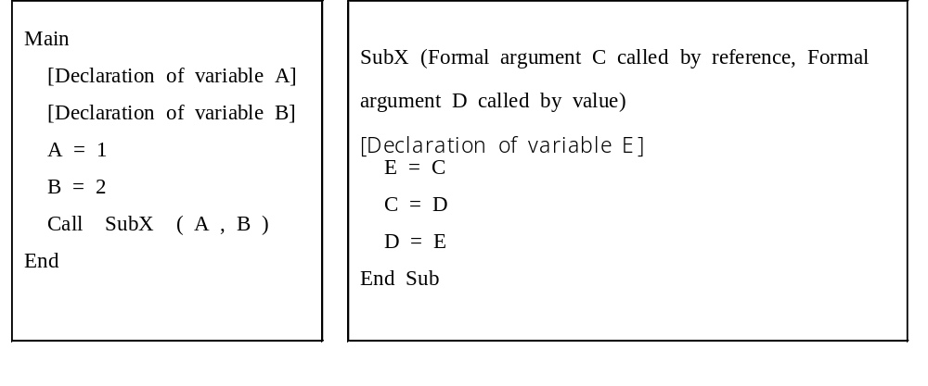

 | A | B
a) | 1 | 1
b) | 1 | 2
c) | 2 | 1
d) | 2 | 2

Q66. Of the following examples of errors, which is detected by the linkage editor?

a) The pairing of parentheses or of braces indicating groups or blocks was incorrect.
b) Declarations of variable names used locally by the program and their attributes were forgotten.
c) Program logic was incorrect.
d) The name of a subroutine to be called was incorrect.

Q67. Which is the most appropriate statement regarding the characteristics of a Gantt chart used in progress management?

a) It allows one to clearly understand the effect on one procedure if another is delayed.
b) It clearly shows the sequential relationship of procedures.
c) It defines the critical path--a point in progress management--to be clearly defined.
d) It allows plans and actual results regarding the daily schedule to be compared.

Q68. Which of the following is the most appropriate to receive approval for when the high-level (external) design of a system is complete?

a) Screen layout b) System development plan
c) Process methods d) Flow chart

Q69. At how many thousands of yen is the break-even point when the items calculated from a profit and loss statement are as given in the table below?

Unit: Thousands of yen
Item | Amount
Total sales | 1,000
Variable costs | 800
Fixed costs | 100
Profit | 100

a) 500 b) 700 c) 800 d) 900

Comment: ‘yen’ should be replaced by the currency unit used in your country.

Q70. Approximately how many thousands of yen is the depreciation for three years if depreciation is performed using the fixed rate method for a device as shown in the table below?

Acquisition cost (thousands of yen) | 1,000
Life expectancy (years) | 5
Residual value (%) | 10
Depreciation rate | 0.369

a) 132 b) 147 c) 180 d) 332

Comment: The same as written to Q69.

Q71. In the case of the tasks shown in the arrow diagram in the figure below, results of a detailed task review found that the time to complete Task D could be shortened by three days. By how many days was the time required to complete all tasks reduced? Assume that the dotted arrow is a dummy task.

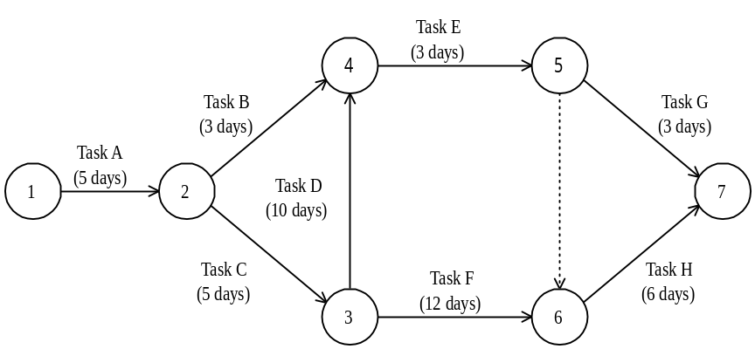

a) 0 b) 1 c) 2 d) 3

Q72. Which is the most appropriate description of a diagram used in product quality control?

a) A scatter diagram is useful in coming to know the fluctuations in single variable data and finding the average value and standard deviation.
b) An affinity diagram is used to gather and organize confusing problem points and inconsistent opinions, ideas, etc.
c) A cause and effect diagram (fish bone diagram) is useful in representing the relationships between two or more variables.
d) A diagrammatic representation used to contrast causes and results, a frequency distribution diagram is used to investigate the cause of failure.

Q73. Which is the most appropriate description of a periodic ordering system used in inventory management?

a) This system is suited for managing A rank goods under ABC analysis.
b) Economical amounts are ordered to minimize the costs of operation.
c) This system is used by the double shelves method.
d) This is also called the ordering point system.

Q74. The following figure is a conceptual diagram of a public key cryptosystem. Which is the correct combination to be inserted in a and b?

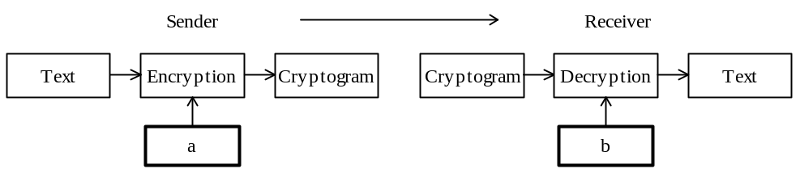

 | a | b
a) | Public key on receiver's side | Private key on receiver's side
b) | Private key on receiver's side | Public key on receiver's side
c) | Public key on sender's side | Private key on receiver's side
d) | Private key on sender's side | Public key on receiver's side

Q75. Which is the most appropriate and effective management method for preventing the tampering and destruction of data by the illegal execution of a utility program?

a) Keeping a system log
b) Comparing the source program with the execution program
c) Backing up data
d) Setting file access privileges

Q76. Which of the following costs is included in the loss caused by destruction of data and loss of system availability?

a) System re-development costs and database porting costs due to changes in the business style.
b) Costs associated with studying the feasibility of system development.
c) Costs associated with alternative procedures until the system is recovered.
d) Costs of transition to the new system.
Q77. Which is the most appropriate statement related to copyrights?

a) A copyright is not secured unless registered with the competent office.
b) The competent office is the Patent Office.
c) The term of validity of a copyright is 20 years.
d) A copyright comes into existence at the point in time a work is created.

Q78. Which is the most appropriate statement related to preventing unfair competition act?

a) If only false information which is harmful to the business reputation of a competing company is spread, the demand for the suspension of such activities or the demand for its compensations cannot be made.
b) Even items of information made public at conferences and through descriptions in brochures given to customers during meetings are protected as corporate trade secrets.
c) Demand for suepension or demand for damage compensation can he made against imitations, including dead copies of another person's product design, and illegal usage of a trade mark which may be mistaken or confused as showing a product or a marketing activity of another person.
d) Even if a logo or symbol is generally widely recognized as representing a particular product, unregistered trademarks and designs are not protected.

Q79. Which of the following is the most appropriate description of the information defined by the product quality assurance standard ISO 9001?

a) It is a product quality assurance model for final inspection and testing.
b) It is a product quality assurance model for manufacturing, installation, and incidental service.
c) It is a product quality assurance model for design, development, manufacturing, installation, and incidental service.
d) It is a guideline for product quality management and product quality system elements.

Q80. Which of the following is an appropriate description for how graphs are used in presentations?

a) Z charts are used to show sales performance in a fixed period and results of analysis of trends in business performance by an enterprise.
b) Circular graphs are used to show the actual state of progress against work schedules.
c) Broken line graphs are used to show the relative merits of product features based on several items that have been evaluated.
d) A scatter diagram is used to show the market share of each company for a product.

